Chapter 3

# Try It Yourself: Describe a Bubble Chart

## Excel Instructions

1. Open the countries.csv dataset in Excel.
2. Check the data.
   1. Ensure you see these columns:   
      prop_internet (Column J), gni_per_capita (Column N), and ggei (Column O).
3. Filter missing data.
   1. Select cells A1:P1
   2. Go to the 'Data' tab on the Excel ribbon at the top of the window.
   3. Click on the 'Filter' button to enable dropdown arrows on the column header.
   4. Click the dropdown arrow in the ggei column header in Column O.
   5. A list of all unique values in the column will appear.
   6. Scroll through the list and find "(Blanks)" and uncheck the box next to it.
   7. Click 'OK' or press 'Enter'.
   8. Click the dropdown arrow in the prop_internet header in Column J.
   9. A list of all unique values in the column will appear.
   10. Scroll through the list and find "(Blanks)" and uncheck the box next to it.
   11. Click 'OK' or press 'Enter'.
   12. There is no need to do the same for gni_per_capita because no values are missing after filtering the missing data for prop_internet and ggei.
4. Select the data.
   1. Select simultaneously these columns:   
      prop_internet (Column J), gni_per_capita (Column N), and ggei (Column O).
5. Insert a bubble chart.
   1. Go to the Insert tab on the Excel ribbon.
   2. Click on the Insert Scatter (X, Y) or Bubble Chart drop-down menu.
   3. Choose Bubble.
6. Adjust the Scale Bubble Size to make them appropriate for your chart.
   1. Right click on one of the bubbles and select Format Data Series.
   2. In the panel under Series Options, click Width of bubbles under Size represents.
   3. Change Scale bubble size to. Type 20, or any number that suits you

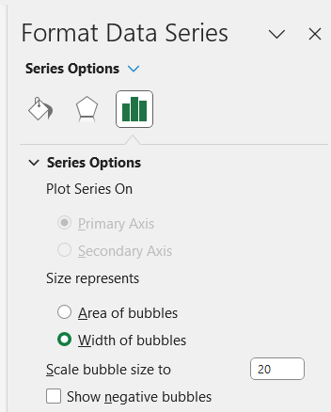

1. Adjust the y-axis, x-axis, and bubble size values.
   1. Once the bubble chart is created, adjust the data series to ensure that:
      1. prop_internet is set as the X-axis (horizontal axis) values,
      2. ggei is set as the Y-axis (vertical axis) values,
      3. and gni_per_capita is set as the bubble size.
   2. To do this, take the following steps:
      1. Right click on the chart, choose Select Data.
      2. Click the Edit button
      3. Under Series name, type “GGEI by Proportion of People with Internet Access”
      4. Under Series X values, type:

=countries!$J$5:$J$177

* + 1. Under Series Y values, type:

=countries!$O$5:$O$177

* + 1. Under Series bubble size, type:

=countries!$N$5:$N$177

* + 1. Click OK.
    2. Click OK, again.

1. Add axis titles and legend.
   1. Click on the chart, then select Chart Elements (plus sign button) on the right side or top of Excel.
   2. Check the boxes for Axis Titles.
   3. Click into the Axis Titles and enter your desired titles for both axes.
2. Create a bubble size legend.
   1. Bubble charts in Excel do not automatically create a legend for bubble size. You can create a manual legend by inserting shapes (circles) of different sizes next to the chart and labeling them with text boxes to represent different GNI per capita values.